AUTONOMOUS BATTLE DAMAGE ASSESSMENT

MODEL DOCUMENTATION
(v1.0-Final)

DOCUMENT HISTORY

DATE | STATUS | VER | AUTHOR | NOTES
20260223 | Draft | 0.1 | Benjamin Siegel | Create model outline
20260302 | Draft | 0.2 | Benjamin Siegel | Write initial draft
20260311 | Draft | 0.3 | Benjamin Siegel | Add evaluation criteria, finalize draft
20260313 | Final | 1.0 | Benjamin Siegel | Formatting changes

Vision Language Models for Battle Damage Assessment

Model Documentation
16 March 2026

Students
- Benjamin Siegel
- Carlos Gil
- Cory Wingate
- Nicholas Lind
- William Benitez

Supervisors & Mentors
- Dr. Rajneesh Singh
- Dr. Priya Narayanan
- Derrik Asher
- Jason Pusey
- CPT Jesse Barkley

1.0 Overview
Battle Damage Assessment (BDA) estimates the effects of military action on targets. In doctrine, BDA “provides the timely and accurate estimate of damage resulting from the application of lethal and nonlethal military force [1].” This project automates key parts of that workflow using post-strike imagery. Specifically, the system identifies relevant targets within a scene and evaluates the level of damage to each object, ultimately producing a structured report so that human analysts can quickly see what was assessed, where it was located, and how damage was categorized.

To accomplish this, the system combines an object detection model with a vision-language model (VLM). An object detector is a computer vision model that identifies individual objects in an image and returns bounding boxes with associated labels [2]. Because real-world imagery often contains many objects, the output is typically a list of detections describing the location and category of each object in the scene. A VLM integrates computer vision and natural language processing so that models can reason about images using text prompts [3].

In this project, the models are used in a zero-shot setting, meaning they are not trained on a task-specific dataset of labeled military imagery. Instead, the models are prompted with target labels and instructions to localize and assess damage directly from the image, leveraging the broad visual and semantic knowledge learned during large-scale pretraining. This capability is particularly useful for BDA because labeled datasets of military equipment and damaged infrastructure are limited, and analysts may need to detect previously unseen equipment types. Typical applications of VLMs and open-vocabulary object detection include scene understanding, image retrieval, and generating structured descriptions of visual content [2], [3]. These capabilities align closely with the requirements of automated BDA, where a system must identify relevant targets in complex scenes and generate structured descriptions of the observed damage.

2.0 Specifications
The overall architecture of the BDA system is shown in Figure 1. Given an input image, the pipeline first localizes candidate targets by doctrinal category, then generates buffered image crops for each detection, and finally prompts a vision-language model to assess damage for each target using both the crop and full-scene context. To maintain doctrinal grounding, only the doctrine relevant to the target’s category is included in the per-target prompt. The VLM outputs are consolidated into a single structured JSON report describing each target’s damage category, confidence level, supporting reasoning, and bounding box.
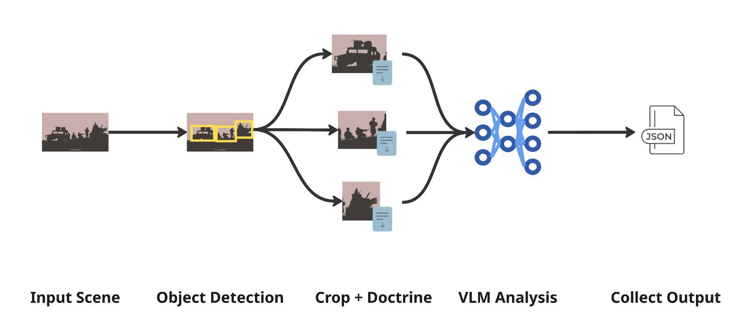
Figure 1: BDA System Architecture

The system is intentionally designed as a modular pipeline that separates localization from reasoning through two abstract interfaces: BaseDetector and BaseVLM. Localization can be performed by a dedicated zero-shot object detector, with the current configuration using Grounding DINO [4]. Some modern VLMs are also capable of performing localization through structured detection prompts [5]. However, not all VLMs reliably produce bounding boxes, and even when they do, a dedicated detection model is typically faster and may produce higher-quality boxes. For this reason, the detection provider is configurable in the system’s configuration file. Detector phrase prompts are also defined in configuration and mapped back to doctrinal categories, and duplicate detections are removed using label-aware non-maximum suppression.

Model backends are loaded via Hugging Face Transformers and Hugging Face Hub, and the intent is to support any downloadable VLM or detector that can be wrapped to satisfy BaseDetector or BaseVLM. The current VLM baseline is Qwen3-VL [6], but it is not the final or only planned option. This modular design is specifically chosen to enable objective comparison of alternative model configurations using both analytical performance metrics (Section 5.0) and operational metrics (inference latency, VRAM usage), while keeping the pipeline contracts and output schema stable.

3.0 Model Run
The BDA system is designed to run locally with no external API calls at inference time, which is consistent with the operational requirements to deploy on a network-degraded edge device. The runtime stack consists of Python 3.12+, PyTorch, Torchvision, Transformers, Accelerate, and Hugging Face Hub, with all dependencies declared in pyproject.toml [7]. All models are downloaded from Hugging Face Hub and loaded locally at runtime. The current baseline uses Qwen3-VL-8B-Instruct-FP8 and Grounding DINO Base, though final model selection will be determined during evaluation. For deployment, the system is packaged as a container image bundling all runtime dependencies alongside model weights, ensuring reproducibility across environments

The system targets deployment to an edge device running Linux with a maximum of 64 GB VRAM, and evaluation is conducted on an NVIDIA H100 NVL GPU capped at 64 GB to match deployment constraints. Computational cost is dominated by VLM generation and scales primarily with image resolution, number of detections per scene, and max_new_tokens. Because the evaluation phase systematically varies pipeline configuration, VLM backend, and model size, each pipeline run emits metrics containing inference time and CUDA memory counters to support direct comparison across configurations. The system runs on local hardware so there are no recurring cloud inference costs, but for reference, equivalent workloads on cloud infrastructure would cost approximately $4 per GPU-hour on an A100 instance [8].

4.0 Training
No training or fine-tuning was performed. The system uses pretrained weights for all models, and adaptation is achieved entirely through prompt engineering and configuration. This zero-shot approach was chosen specifically because labeled datasets of military equipment and damaged infrastructure are scarce, and the system must generalize to previously unseen equipment types without retraining. An additional benefit is that the modular, zero-shot design allows new models to be integrated and evaluated as the field evolves, without requiring a retraining pipeline.

5.0 Evaluation
A major goal of this project is to objectively evaluate how well the system performs automated battle damage assessment. To support this evaluation, a dataset of over one hundred human-annotated scenes with reference labels has been collected. Because the BDA system produces structured outputs describing individual targets in a scene, evaluation is performed at the target level. Each target is defined by four attributes: a doctrinal target category, a doctrinal damage category, a confidence level, and a short textual explanation describing the supporting visual evidence.

Within a scene, predicted targets must first be matched to their corresponding reference targets. A predicted target is eligible to match a reference target only if they share the same target category. Since predictions and references include bounding boxes, spatial alignment serves as an additional matching requirement. Spatial alignment is measured using Intersection over Union (IoU) between bounding boxes. For each pair that shares the same target category and meets a minimum IoU threshold, the predicted attributes (i.e. Damage Category and Confidence) are compared against the reference attributes. Attributes are treated as ordinal values, reflecting that predictions such as “destroyed” are closer to “severe damage” than to “no damage.” Attributes with a greater disparity are penalized more heavily.

Once every reference target is compared against every predicted target using the aforementioned criteria, an optimal matching can be computed such that each prediction is paired with at most one reference target (subject to threshold settings). Once matching is established, detection outcomes are defined as follows:

- True Positives (TP): Predicted objects that match a reference object
- False Positives (FP): Predicted objects with no corresponding reference
- False Negatives (FN): Reference objects missed by the system

Finally, a large language model acting as a judge [9] evaluates the logical quality of each target assessment. The judge assigns an integer score from zero to two based on whether the explanation is consistent with the facts in the reference label. This produces a target-level score combining structured accuracy components and logical consistency. Scene-level performance is computed by aggregating the target scores, normalizing by the number of reference targets, and applying penalties for false positives and false negatives.

This evaluation framework is designed to capture the key capabilities required for automated BDA: accurate localization of targets, correct assessment of damage severity, calibrated confidence estimates, and logical explanations of the observed damage. Currently, formal evaluation has not yet been conducted, but the framework described above will be used to compare alternative system configurations. In particular, it enables objective comparison across different model variants and model sizes while also tracking operational metrics such as inference time and GPU usage. These results will help determine which model configuration provides the best balance between analytical accuracy and computational efficiency for deployment on edge hardware.

6.0 Reflection
Working on this document helped us formalize the evaluation procedure and clarify the reference data format, particularly the need for bounding boxes to enable precise target matching and scoring. It also reinforced the value of separating detection from reasoning, as we have seen better results by breaking the overall task into smaller, well-defined steps. Overall, documenting these decisions made our design choices more deliberate and clarified how each component contributes to the overall system.

7.0 Changes To Previous Deliverables

A major change from earlier deliverables is the separation of detection and reasoning. Previously, the pipeline relied solely on a VLM to both detect targets and generate full-scene reports, occasionally producing bounding boxes when supported by models like Qwen-VL. We refined this approach by introducing a dedicated detector to generate bounding boxes and passing cropped targets to the VLM along with relevant doctrinal guidance. This change makes the task more manageable, and allows the system to work efficiently within our model size constraints.

References

[1] Joint Chiefs of Staff, CJCSI 3162.02A: Methodology for Combat Assessment. Washington, DC, USA: Joint Staff, Jul. 16, 2021.

[2] Hugging Face, “Object detection,” Hugging Face Documentation. [Online]. Available: https://huggingface.co/docs/transformers/tasks/object_detection. [Accessed: Mar. 14, 2026].

[3] Hugging Face, “Vision-language models (VLMs),” Hugging Face Blog. [Online]. Available: https://huggingface.co/blog/vlms. [Accessed: Mar. 14, 2026].

[4] Hugging Face, “Grounding DINO,” Hugging Face Documentation. [Online]. Available: https://huggingface.co/docs/transformers/en/model_doc/grounding-dino. [Accessed: Mar. 14, 2026].

[5] Qwen Team, “Qwen3-VL Technical Report,” arXiv:2511.21631, 2025. [Online]. Available: https://arxiv.org/abs/2511.21631. [Accessed: Mar. 14, 2026].

[6] Qwen Team, “Qwen3-VL,” GitHub repository. [Online]. Available: https://github.com/QwenLM/Qwen3-VL. [Accessed: Mar. 14, 2026].

[7] cmu-bda, “bda-svc,” GitHub repository. [Online]. Available: https://github.com/cmu-bda/bda-svc. [Accessed: Mar. 14, 2026].

[8] Microsoft, “Azure pricing calculator,” Microsoft Azure. [Online]. Available: https://azure.microsoft.com/en-us/pricing/calculator/. [Accessed: Mar. 14, 2026].

[9] Z. Li et al., “A Survey on LLM as a Judge,” arXiv:2411.15594, 2024. [Online]. Available: https://arxiv.org/abs/2411.15594. [Accessed: Mar. 14, 2026].

